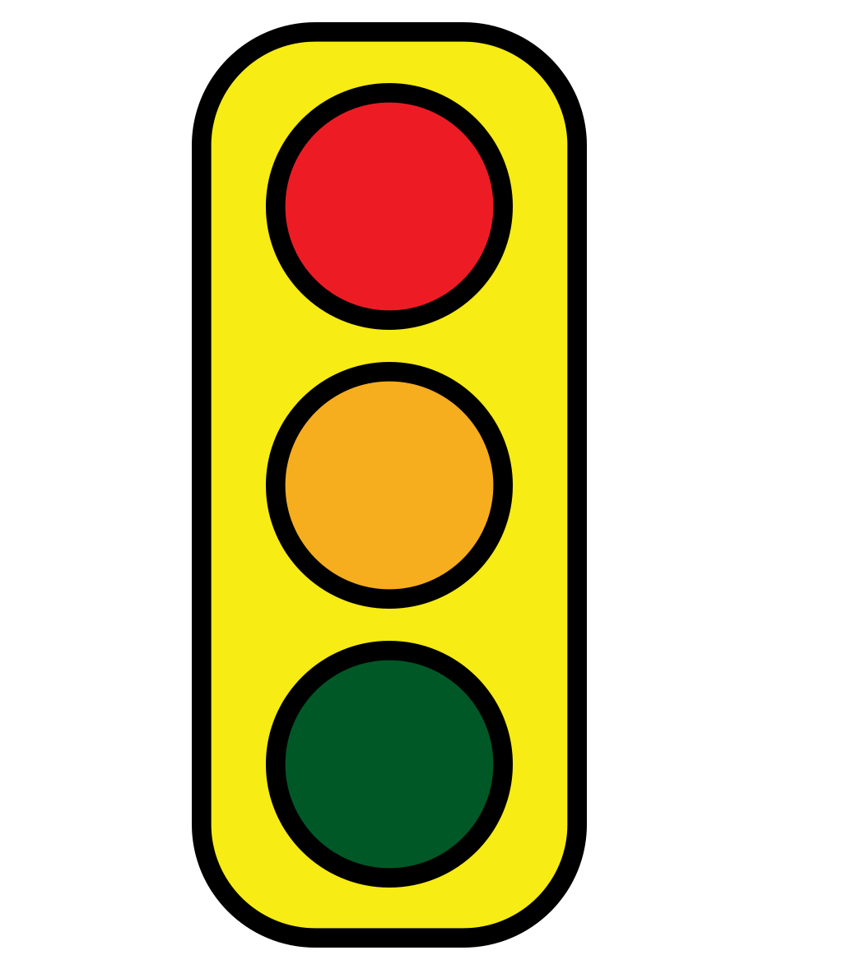
Book Proposal Viability Assessment
©Margot Starbuck & Sarah Arthur

Author

Book Title

Fiction or Nonfiction?

Address line 1

Address line 2

Contact phone

Email

Website

Twitter/Instagram Handle

The Project: Has the author offered a unique and compelling premise?

Summary: [1-2 brief paragraphs description of the plot, similar to back cover copy.]

Details
Approximate word count:
Seeking Traditional Publication or Self-Publishing?
Traditional Publisher Self-Publishing
Part of a series? Yes No
Does this book relate to cultural trends or current events? Yes No
(If Yes, please offer one sentence of explanation)

The Hook: Has the author offered a compelling hook to draw in the reader?

1-2 sentence hook: [Your elevator speech for this project that will hook editor/reader’s attention.]

The Market: Are there readers, with a palpable felt-need, waiting to read this book?
Target Audience & Similar Books:
Answer the following:
- Who is your target readership or tribe? (1 sentence)

- What itch does this scratch for them? What is reader’s felt need that this book meets? (1 sentence)

- What other similar titles or kinds of books does this group like? (3-5 titles)

- How is your book different? (1 sentence)

The Platform: Has the author built a platform that will sell books?

Author credentials & platform:
- List publishing experience
  - If you’ve published books, list: (1) Title (2) Publisher (3) Year (4) Number of copies sold.

  - If you’ve published articles, share the 3 of which you’re most proud: (1) Magazine (2) Title of Article (3) Link, if available

- Guilds or groups to which you belong

- Number of social media followers
  - Facebook
  - Twitter
  - Instagram
  - LinkedIn
  - Other
- Blog/Podcast URL
  - Number of blog subscribers and/or podcast downloads
- Pertinent teaching and/or speaking experience (List speaking engagements over last 12 months and how many people in each audience)

- Educational background (List each institution and degree)

- Honors & awards (Share name of award, year)

- Possible endorsers (Know anyone famous? List 5-10 potential endorsers)

- Why are you the best person to write this book? (2-4 sentences)

The Writing: Does the writing shine? Is the reader longing to turn the next page?

- Table of Contents

- Brief chapter summaries (2-3 sentences summarizing content of each chap.)

- Sample writing: (Please include sample writing as email attachments.)
  - Nonfiction: please submit the first chapter of this book and your favorite chapter. (Introduction not requested.)
  - Fiction: please submit first two full chapters.

Other…

Anything we haven’t asked that a publisher should know? (Are you executive director of an international organization? Sister of a national talk show host? NFL MVP? Etc.)

